
A10/A12
Sreenidhi Institute of Science & Technology
(An Autonomous Institution)
Code No: 111ME02/121ME02
B. TECH. I – Year II – Semester Examinations, JUNE, 2014 (Supplementary)
ENGINEERING DRAWING – II (Common to All Branches)

Time: 3 Hours Max. Marks: 70

Note: No additional answer sheets will be provided.

Part - A (Objective Type)
Max.Marks:20

Answer all QUESTIONS.
1. What is the difference between a plain scale and diagonal scale?
2. Explain the two different types of vernier scales.
3. Name the methods of development of surfaces.
4. Differentiate between a transition piece and reducer.
6. List out the pictorial views.
7. Define CAD.
8. Name the coordinate systems.
9. What is the difference between isometric projection and oblique projection?
10. What is isometric scale?

Part – B
Max. Marks: 50

ANSWER ANY FIVE QUESTIONS. EACH QUESTION CARRIES 10 MARKS.
1. Draw a plain scale of1:60 to show 3.6 metres and long enough to measure up to 6 metres.

2. Construct a diagonal scale of R.F =1/32 and to measure up to 4 yards. Show 3 yards 1feet 6 inches.

3. A cylinder of diameter of base 40 mm and axis 60 mm long, is resting on its base on H.P. it is cut by a section plane, perpendicular to V.P and inclined at 45º to H.P. the section plan is passing through the top end of an extreme generator of the cylinder. Draw the development of the internal surface of the cut cylinder.

4. Draw the isometric view of the below figure.
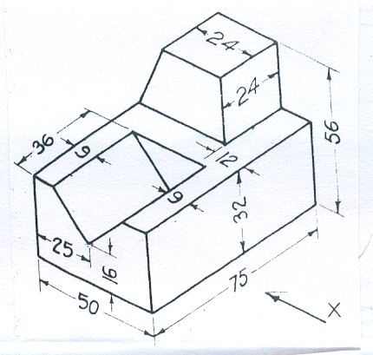

5. Draw the orthographic views of the below figure.

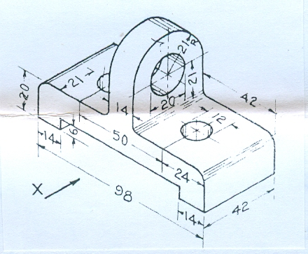

6. Draw the orthographic views to isometric view of the below figure.

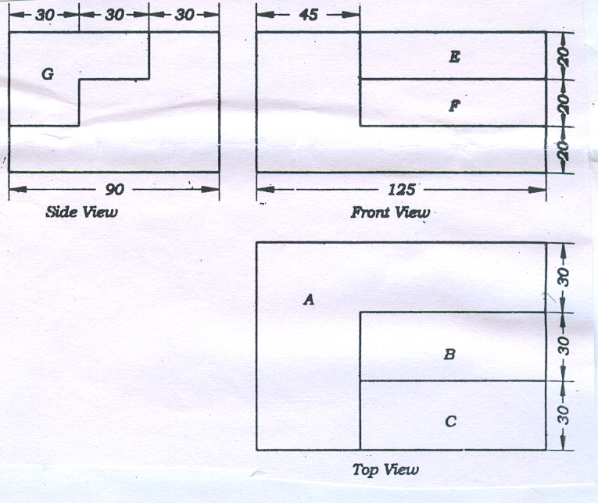

7. Draw the perspective projection of a straight line AB, 60mm long is parallel to and 10mm above the ground plane and inclined at 45º to PP. the end A is 20mm behind the picture plane. Station point is 35mm in front of the picture plane and 45mm above the ground plane and lies in a central plane passing through the mid point of AB.

8. a) what are the benefits and applications of CAD?
b) what are the input and output devices of CAD?

-- 00 -- 00 --

